*Florida International University*

*School of Computing and Information Sciences*

CIS 4911 - Senior Capstone Project

Software Engineering Focus

Feature Document

User Story #700

**Team Member:**

Andrew Mitchell

**Product Owner(s)**:

Francisco R. Ortega

**Mentor(s)**:

Francisco R. Ortega

...

**Instructor**: Masoud Sadjadi

**User Story –** Add Real Sense to Override Mode

* As a User I would like to toggle on and off the RealSense Device and its functionality so I can use the device how I want.

Acceptance Criteria

* Enable a real sense button into the override devices menu.
* Add a button to enable and disable all realsense functionality (at least including expressions).

**Use Case**

Use Case

Enable real sense override mode to disable and enable the real sense and certain functionality.

Details:

Actor: User

Pre-conditions:

Multitouch must be running.

Real Sense must be running.

Description:

Use case begins when the user touches the ‘device modes’ button. The user then pulls up a menu in which they can toggle the real sense on and off as well as its functionalities.

Post-conditions:

After selecting a specific box, that device must be ‘off’ in the context of our program.

Decision Support:

Frequency: Often. The User will want to choose which way to use the real sense and find which way feels the best to them.

Criticality: High. Since the program is for learning about how users can interact with multiple devices, controlling which device functionality we are working with is a huge plus!

Risk: Low. Override mode is a new feature, adding additional functionality should not be too hard.

Reliability: Highly.

Mean time to Failure –  Almost never. It should only ‘fail’ when the user misses the button, or the device is not connected.

Availability –Available when Multitouch is enabled. Buttons can only toggle on device functionality if the device is plugged in!

Performance:

N/a

Supportability:

Acer Multitouch.

Real Sense SR300 depth camera.

Modification History:

Owner: Andrew Mitchell

Initiation date: 4/5/2016

Date last modified: 4/6/2016

**Use Case Diagram**

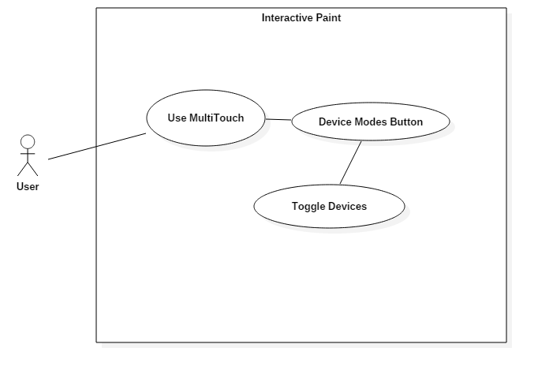

**Sequence Diagram**

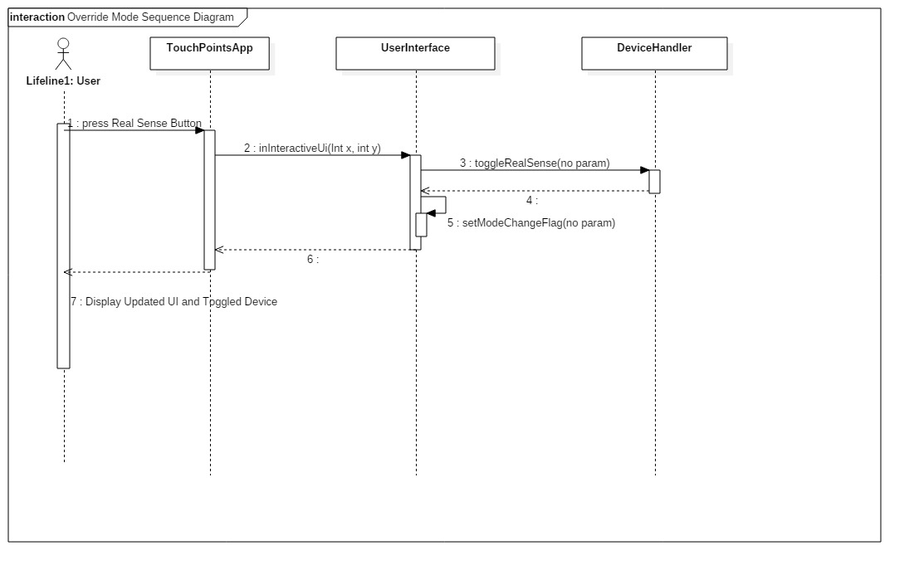

Real Sense Expressions Sequence is the same, using its ‘toggleRealSenseExpressions()’ instead of toggleRealSense(), as well as the user pressing the appropriate button.

**Class Diagram**

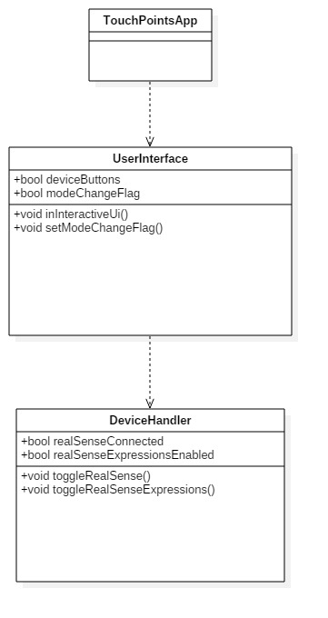

**Unit Test**

Sunny Day:

Test Case: Toggle Real Sense

Test Purpose:

Ensure that touching override Real Sense button correctly turns off the real sense functionality as well as turns on (if the device is actually plugged in).

Test Setup:

1. Have real sense plugged in
2. Press the ‘Device Modes’ button in the mode box
3. Press the ‘Real Sense’ button (toggles it off)
4. Try to perform expressions
5. Press the ‘Real Sense’ button (toggle it on)
6. Try to do Expressions.

Test Output:

After toggling the real sense off the user could perform any sort of expressions to change settings. In addition when toggling off the real sense the ‘Real Sense Expressions’ button also was toggled off. Once they toggle the button back on, the user successfully could perform expressions. They could change the shape with a smile, as well as change shape with a puffy cheek.

Expected Output:

When the real sense is ‘off’ you cannot use expressions to change brush settings. In addition it should ‘shut down’ the real sense expressions button.

When the Real Sense is on you can use expressions to change shape, as well as color.

Sunny Day:

Test Case: Toggle Real Sense Expressions

Test Purpose:

Ensure that touching the Real Sense Expressions override button correctly turns off the real sense functionality as well as turns on (if the device is actually plugged in).

Test Setup:

1. Have real sense plugged in
2. Press the ‘Device Modes’ button in the mode box
3. Draw 3 simple shapes (Lines, circles, or rectangles)
4. Make sure the ‘Real Sense’ button is on and green.
5. Press the ‘Real Sense Expressions’ button (toggles it off)
6. Try to perform expressions
7. Press the ‘Real Sense Expressions’ button (toggle it on)
8. Try to do Expressions.

Test Output:

After toggling the real sense off the user could perform any sort of expressions to change settings. Once they toggle the button back on, the user successfully could perform expressions. They changed the shape with a smile, as well as change shape with a puffy cheek. When doing a raised eyebrow the device called the undo function on our shapes.

Expected Output:

When the real sense expressions is ‘off’ you cannot use expressions to change brush settings.

When the Real Sense Expression was on is on you can use expressions to change shape, as well as color.

Rainy Day Tests:

Test Case: Toggle Disconnected Real Sense

Test Purpose:

Make sure you cannot ‘enable’ a device when it is not connected.

Test Setup:

1. Start the program with only multitouch plugged in
2. Toggle the Device Modes menu
3. Tap ‘Real Sense’ button
4. Tap the ‘Real Sense Expressions’ button.

Test Output:

* After tapping the Real Sense button the box stayed black
* After tapping the Real Sense Expressions button the box stayed black.

Expected Output:

No boxes should turn black when tapping on them, since the device is not plugged in.

**Integration Test**

The Device Modes buttons currently work with all implemented devices (excluding real sense which is in development this sprint).

Toggling on and off devices still leaves the functionality intact.

Toggling on and off the real sense or its expression functionality leaves all the other devices intact, allowing you to continue to use the leap, eyex, or multitouch (Though some ‘Infrared’ interference occurs when all the devices are connected).

Currently integrated with the new Real Sense Draw functionality!

**User Guide**

Press the ‘Device Modes’ button in the ‘Mode’ box. This will pull up a menu where you can enable or disable any given device and their functionality by pressing their respective buttons.

To access the ‘override’ modes functionality you must first click the ‘Device Modes’ button located on the top right corner of the mode box displayed in this image.

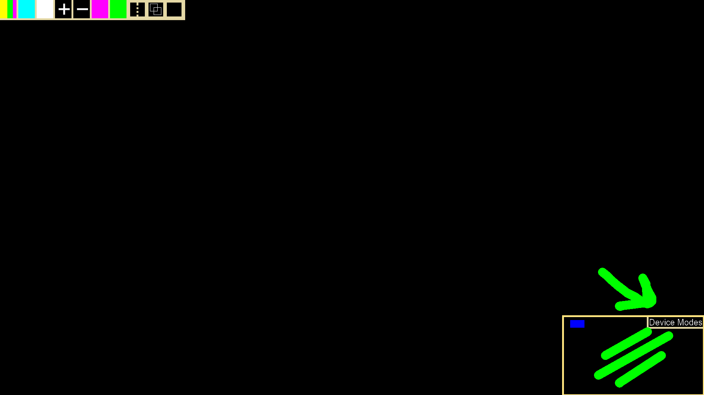

After pulling up the mode box you can toggle on and off the Real Sense device using the Real Sense button. As well as specific functionality for the real sense device using ‘Real Sense Expressions’. A green box indicates that the device or functionality is currently active (See Multitouch button) while the blacked out box means that the device or functionality is currently off (Real Sense all the way down to EyeX)

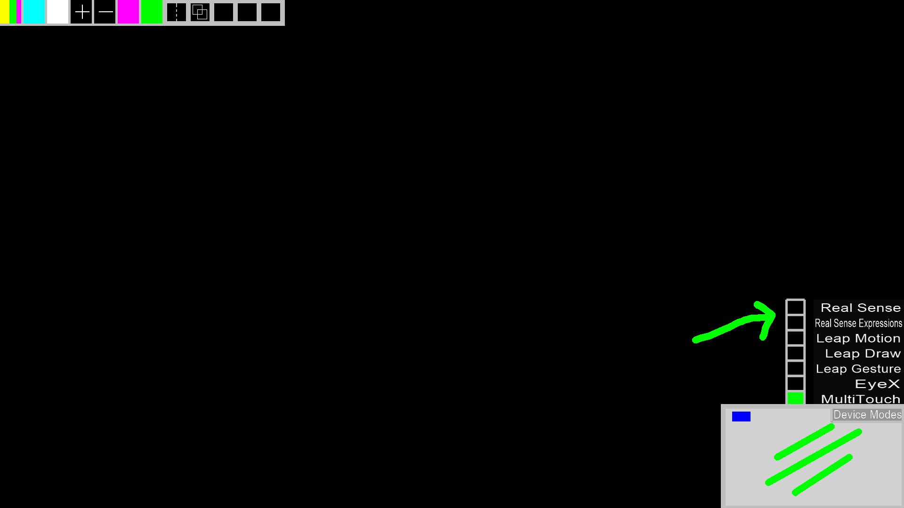

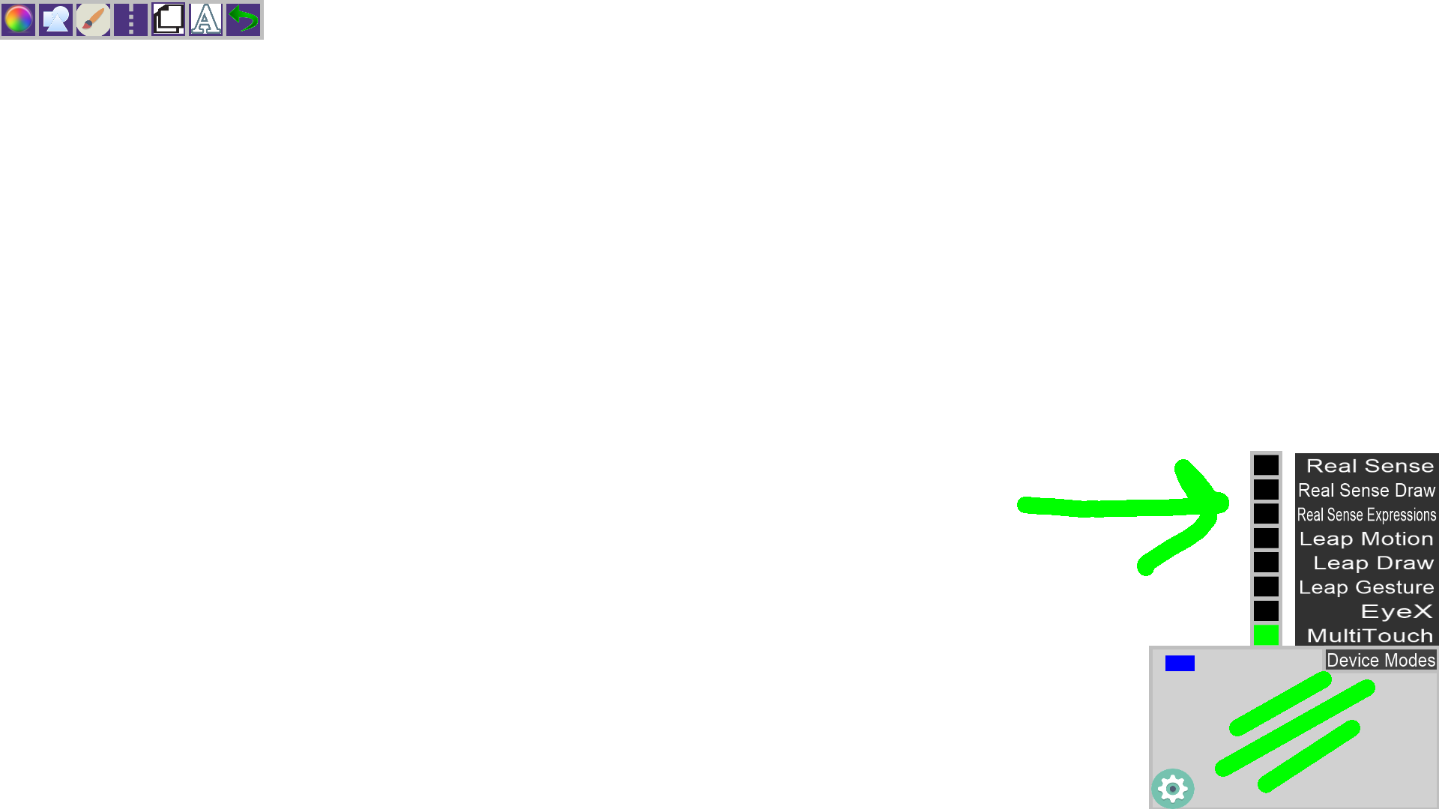

Currently integrated with real sense drawing as well!

**Glossary**

Device Modes – These modes help display and show you which devices are available and which functionality they will provide.

Real Sense – The Intel Real Sense SR300 Depth camera. A camera that can detect depth of a person and their hand. As well as reading expressions on their face etc.

Real Sense Expressions – Real Sense Functionality which detects facial expressions, such as a smile, eye raise, puffy cheeks, or tongue out.